**Difference between Python 2 and Python 3 Version**

**The Companies are moving from Python version 2 to 3 because:**

* Python is not traditionally a typed language, but Python v3.5 supports typing, which removes development conflicts when working new pieces of code.
* Each newer version of Python continues to get faster runtime. Meanwhile, nobody’s currently working to make Python 2.7 work faster.
* Community support is better with Python 3.

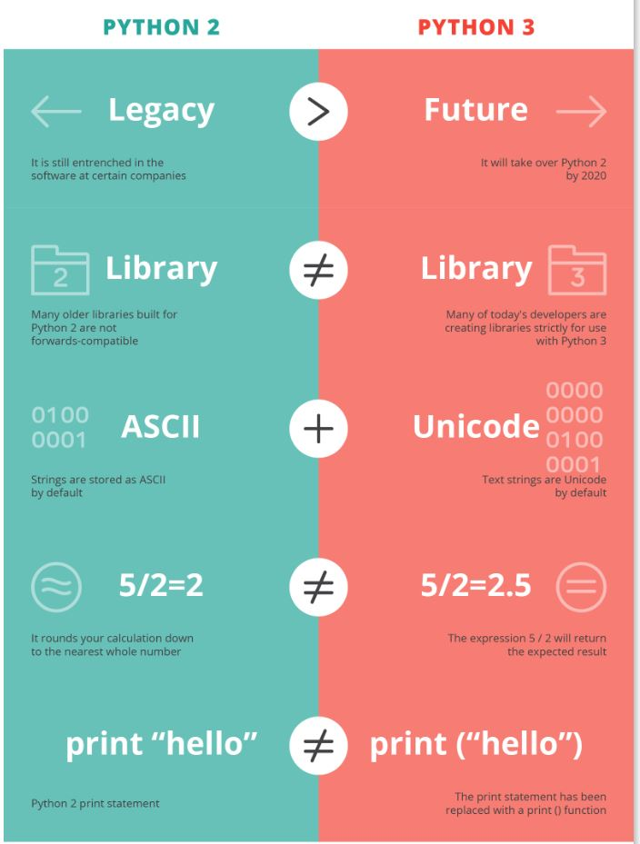

**The few differences based on specific features are mentioned below:**

1. **Division operator**

print 7/5

print -7/5

Output in Python 2

1

-2

Output in Python 3

1.4

-1.4

1. **Print function**

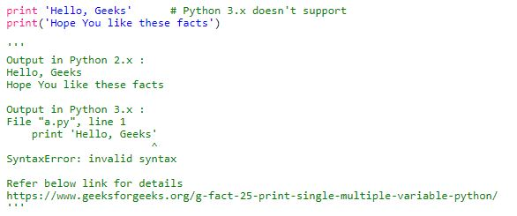

1. **Unicode**

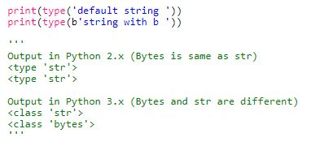

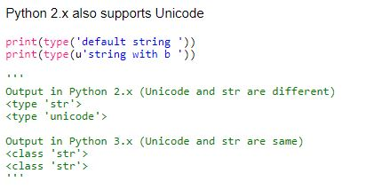

1. **xrange**

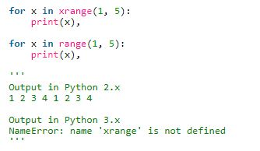

1. **Error Handling**

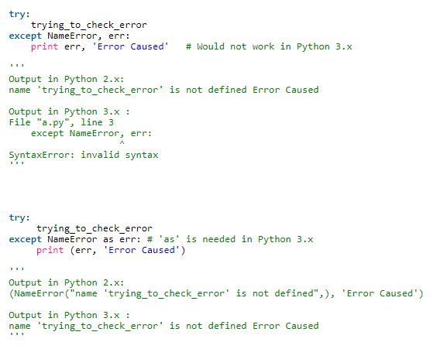

1. **Raising exception**

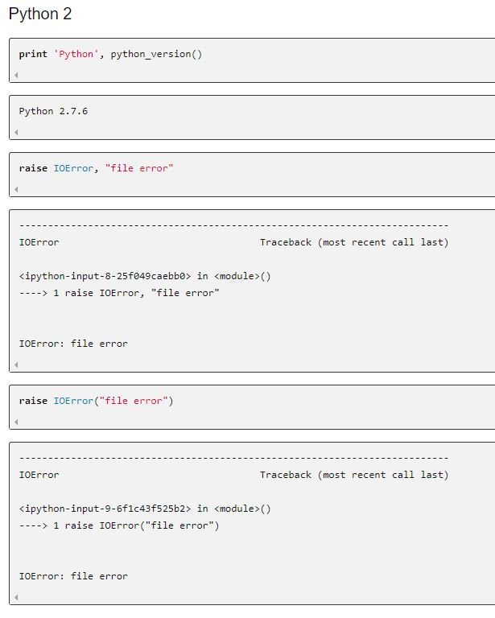

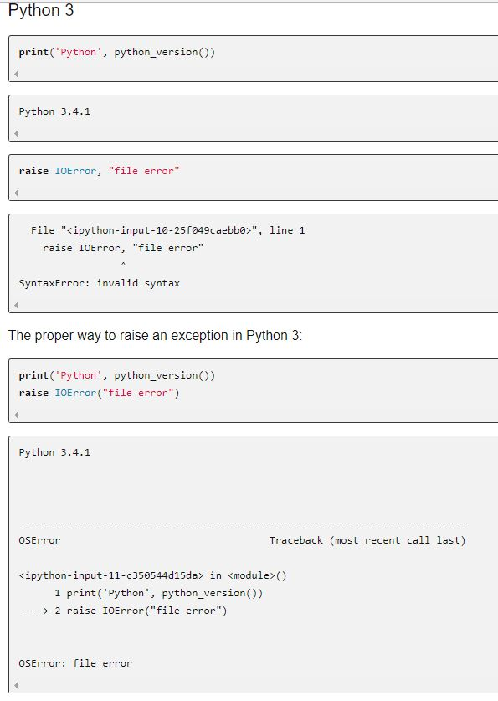

**Handling Exception**

**Speed Difference:** Its pointed out that the speed difference between Python 3’s range() and Python2’s xrange(). Since they are implemented the same way one would expect the same speed. However the difference here just comes from the fact that Python 3 generally tends to run slower than Python.

